GEOSCIENCE STUDY GUIDE FOR LAND AND SEA BREEZES
- Wind is moving air
- Air moves because the surface underneath it affects its temperature
- Hot surfaces will heat the air by conduction. Cool surfaces will cool the air above.
- Warm air rises, then cool air moves in to take its place. The horizontal movement of air is wind (or breeze)
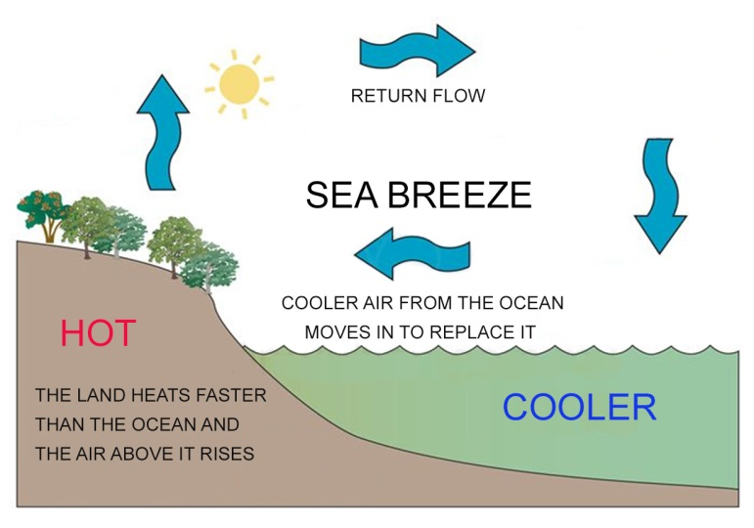
WHY LOCAL WINDS CHANGE DIRECTIONS
- The temperature of the land (soil) changes drastically during a 24 hour period. This is due to the LOW SPECIFIC HEAT and LOW ALBEDO of the soil. Therefore the air above the land changes temperature quickly over a 24 hour period.
- ALBEDO IS THE REFLECTIVITY OF A SUBSTANCE. High albedo substances are light colored and often shiny. Low albedo substances are dark colored.
- LOW ALBEDO substances absorb light and get warmer quickly
- The temperature of air above a low albedo substance will get warmer quickly during the day
- Warm air expands and becomes less dense.
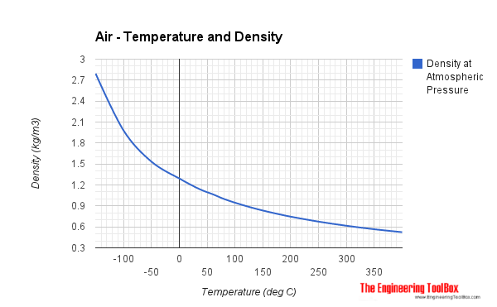
Less dense air rises and creates a low pressure zone
- The temperature of the ocean changes very slowly during a 24 hour period. This is due to the HIGH SPECIFIC HEAT AND HIGH ALBEDO OF WATER. Therefore the air above the water changes very slowly over a 24 hour period.
- SPECIFIC HEAT IS THE AMOUNT OF ENERGY IT TAKES FOR A SUBSTANCE TO CHANGE TEMPERATURE BY ONE DEGREE CELCIUS
- Water has a high specific heat and will maintain almost the same temperature all day because it takes a lot of energy to change it
- EVENTUALLY the land temperature will become cooler than the temperature of the ocean. This makes the air above the land cooler than the air above the ocean, even though the ocean’s temperature did not change much. Cool air contracts and becomes denser. More dense air sinks and increases in pressure.
- Air moves from high pressure areas to low pressure areas as wind
- During the day a SEA BREEZE IS CREATED.
- DURING THE NIGHT, A LAND BREEZE IS CREATED.
